***Alfred Stanley Cheadle***

[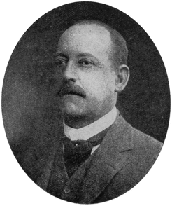](http://oa.anu.edu.au/uploads/obituaries/214/cheadle_a_obit_image_1923.gif)

**Alfred Stanley Cheadle (1853-1923)**, born in Yorkshire, was initiated into the manufacturing and marketing of woollen materials there, and gained more experience in France. He returned to England as a wool-buyer and salesman for relatives who were worsted spinners.

Alfred migrated to South Australia in the saloon of the ‘City of Adelaide’ in 1880, to a job on Sir Thomas Elder’s Beltana Station. Later he worked in the wool department of Elder, Smith & Co., for four years, then became wool department manager of the NZ Loan and Mercantile Agency Co. when it opened a branch in Adelaide.

The company withdrew from SA in 1895, and Cheadle and Mr R. Strachan succeeded to the business as Strachan, Cheadle & Co. When this was incorporated into Dalgety & Co. Ltd, Cheadle became director of their wool department.

***Family of Alfred Stanley Cheadle***

Alfred Stanley Cheadle (1853-1923)

m. Margaret Loutit (1865-1946) m. 1886, South Australia

(1) Thomas Stanley Cheadle (1887-1959)

m. Norah Rivoli Murphy (1898-1962) m. 1928, South Australia

(2) Agnes Cheadle (1891-1973)

m. James Hugh Paterson Davis (1880-1967) m. 1911, South Australia

(1) Agnes Magaret Davis (1912-

(2) Hugh Paterson Davis (1915-1965)

(3) John Paterson Davis (1916-1989)

m. Claire Margaret Green (1921-2007) m. 1955, South Australia

(1) Anna Davis

(2) Joan Davis

(3) Charles Davis

(4) Richard Paterson Davis (1919-1942)

m. Nancy McKellar Barratt (1916-1990) m. 1941, Victoria

(3) Mary Alison Cheadle (1896-1983)

m. Jefferson Hirst Walker (1901-1941) m. 1929, South Australia

(4) Frances Margaret Cheadle (1900-1995)

m. Dominic Mary Paul McGuire (1903-1978) m. 1927, South Australia

(5) Peter Roland Cheadle (1906-1985)

m. Jessie Stodart (1902-1997) m. 1932, South Australia

Alfred Stanley Cheadle

(parents – Peter Flett Cheadle, occupation – manufacturer of woollen goods and Eliza Wood )

(she remarried to Alfred *James* Mellor, Melbourne)

Born – 15th June, 1853, Halifax, Metropolitan Borough of Calderdale, West Yorkshire, England

Baptism – 8th March, 1854, St Peter, Yorkshire, England

Died – 5th January, 1923, Victor Harbor, South Australia (bk459/pg215)

Aged – 69 years

Buried – Saint Judes Cemetery, Brighton, South Australia

Occupation – Wool Broker, property at Beltana, SA

Employed at Thomas Elder at Beltana Station; Elder Smith & Co., for four years; New Zealand Loan & Mercantile Agency as the Adelaide manager for the wool and produce department (closed in 1895); Cheadle and Roland Strachan took over the business renamed it to Strachan, Cheadle & Co., and later that was taken over by Co.Dalgety & Co. Ltd. Cheadle, Crase & Co (wool broking firm), which bought by Bennett & Fisher Ltd in 1919

Interests – Adelaide Chess Club; Chamber of Commerce (Adelaide); examiner of woolclassing South Australian School Mines and Industries; member of St Peters Town Council and mayor 1892-1894.

Arrived aboard the City of Adelaide with his mother Eliza Mellor and James Mellor (step-father)

Residence – Medindie; Mount Lofty – “The Shay”; Holiday cottage – “Little Shay”

Married – 28th January, 1886, Congregational Church College Park, South Australia (bk146/pg501)

Margaret Loutit

(parent – Thomas Flett Loutit and Jane Freeman)

Born – 14th January, 1865, Gawler, South Australia (bk512/pg34)

Died – 29th July, 1946, North Adelaide, South Australia (bk3540/pg703)

Aged – 81 years

Buried – Saint Judes Cemetery, Brighton, South Australia

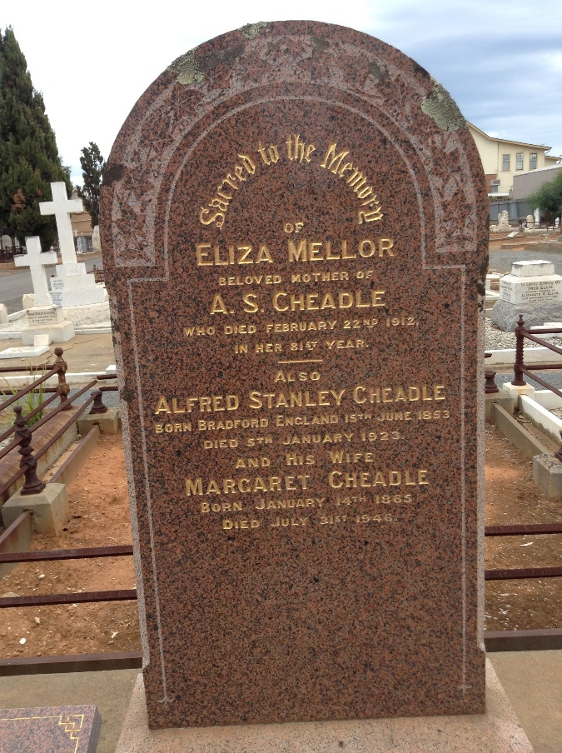

***Newspaper Clippings***

***Border Chronicle, dated Friday 9th May, 1919***

IMPORTANT BUSINESS AMALGAMATION

The well-known firms of Messrs Bennett & Fisher and Messrs Cheadle, Crase & Co. have amalgamated the stock and station agency and wool brokerage businesses hitherto carried on by them respectively, and the amalgamated businesses will hereafter be carried on by Bennett and Fisher, Limited. This company, which has a capital of £200,000, will take over both the businesses as going concerns, and continue all the operations of the late firms as stock and station agents and auctioneers and wool and grain and produce brokers.

The headquarters of the new enterprise, concerning which an advertisement appears elsewhere in this issue, will be at Bowman buildings, King William street, Adelaide, the present business centre of the late firm of Messrs Bennett and Fisher. The company intends to make available for its many clients the best accommodation possible, and with a view thereto plans have already been prepared for the erection at Port Adelaide of the commodious and up to day appointed wool and grain store. The history of the progress of these firms is very much a history of this State, so long ago is it that they commenced business, and so wide and important have been their clientele. It is now over 60 years since the firm of Messrs Bennett & Fisher was established in – it is true – a very small way. Such, however, have been the care and attention the firm has given to its clients’ interests that it has made steady progress, and is today one of the largest and most important undertakings of its kind in this State. That this is no empty boast is made plain by some figures which out reporter has extracted, showing the sales of stock sold by stock agents at the Metropolitan Abattoirs yards from January 1 to date.

The figures show that Messrs Bennett & Fisher have sold more cattle, lambs and calves than any other agent in the Adelaide Stock Salesman’s Association, while they have only been beaten by one firm in the number of pigs sold and by two firms in the number sheep sold.

It is in response to the requests of numerous clients that the enterprise has been extended to wool and grain brokering, and in this connection no name is a greater guarantee of skill and integrity that that of Mr Alfred Stanley Cheadle, the senior partner of the late firm of Cheadle, Crase & Co. The company has a strong directorate - Messrs A. G. Rhymill (Chairman), K. D. Bowman (of Poltalloch), A. A. Scarfe, T. S. Cheadle and Hugh Davis. Mr Hugh Davis will be the managing director, and the company has been fortunate in securing his services – as it was to his ability and energy that he great progress of the business of Messrs Bennett & Fisher was largely due. The customers and clients of the company can feel assured that their interests will be well looked after by such directors and managing director. Of the 200,000 shares of £1 each consisting of the capital of the company 125,000 shares of £1, and 75,000 share, the balance of the shares, will be held in reserve. No application for capital will be made to the public. A special feature of the formation of the company, is the introduction of the principle of co-operation, and to this end a limited number of shares will be reserved by the directors for issue to the employees and customers of the company, who have expressed a desire to become interested in the enterprise. By this means the hearty co-operation of all interested will be secured on a profit – sharing basis. Mr Hugh Davis, assisted by Mr Sam Helpman, will continue to five his special care and attention to the stock department, while the wool and grain department will be under the direct supervision of Mr Tom Cheadle, who has only recently returned from the war, assisted by Mr. A. V. Crase a member of the former firm of Messrs Cheadle, Crase & Co.

***Observer, dated Saturday 13th January, 1923***

**DEATH**

**CHEADLE –** On the 5th January, at Victor Harbour, Alfred Stanley Cheadle, of the “Shay” Mount Lofty, aged 69 years.

**OBITUARY**

**Mr Alfred Stanley Cheadle**

A notable figure in the wool trade in South Australia, Mr Alfred Stanley Cheadle, passed away on January 5th at Victor Harbour. The end came suddenly, although it was not unexpected, as it followed upon a severe seizure which occurred several months ago. Mr Cheadle, who was 69 years of age, was a native of Bradford, Yorkshire, and at the centre of the woollen industry was initiated into the business of manufacturing and marketing wool. After two years’ experience at Roubaix, France, he returned to England, and acted as wool buyer and salesman for relatives who were wool spinners. In 1880 he came to Adelaide, and received an appointment on the Beltana Station, belonging to the late Sir Thomas Elder. Later he was given a position in the wool department of Elder, Smith & Co., Limited, of Adelaide, and after four years he accepted the management of the wool and produce department of the New Zealand Loan and Mercantile Agency Company, when that concern opened its Adelaide Branch. The company relinquished operations in South Australia in 1895, and Mr. Cheadle, with Mr R. Strachan, succeeded to the business, which they carried on under the style of Strachan, Cheadle & Co. It was subsequently incorporated with Dalgety and Co., Limited, and Mr Cheadle became director of the wool department. Mr Cheadle was one of the best known wool salesmen in the State, and had an extensive and intimate knowledge of the pastoral industry in the State and Commonwealth. He was twice Mayor of St Peters, and was a member of the St Peters Corporation for a number of years. He was a past President of the South Australian Chambers of Commerce and an examiner in wool classing at the South Australian School of Mines and Industries. Mr Cheadle married in 1886, Miss Margaret Loutit, and had a family of three daughters and two sons.

**Cheadle, Alfred Stanley (1853–1923)**

from ***Pastoral Review***

One of the best known figures in the South Australian wool trade passed away on 5th January at Victor Harbor, in the person of Alfred Stanley Cheadle, at the age of 69 years. For many years he wielded the hammer at the Adelaide auctions as wool salesman for various firms with which he was associated. He had an intimate knowledge of the pastoral industry, not only of the State, but of the Commonwealth, and few were better versed than he in wool and stock affairs. He was bred and born among wool, as it were, having first seen the light of day in Bradford, Yorkshire, where for generations his ancestors had been in business. There in due course he was initiated into the processes of manufacturing and marketing wool. Two years were spent in Roubaix, France, and then he went back to England and acted as woolbuyer and salesman for his wool spinning relatives.

He went to Adelaide in 1880, and for some time was engaged on the late Sir Thomas Elder's Beltana Station. Later he joined the wool department of Elder, Smith and Co. Limited, Adelaide. After four years with that well-known firm he accepted the position of manager of the wool and produce department of the New Zealand Loan and Mercantile Agency Co., when that company established an Adelaide branch. In 1889 the company relinquished its connection, and Mr. Cheadle, with Mr. R. Strachan, succeeded to the business, which they carried on under the title of Strachan, Cheadle and Co. In due course this firm was absorbed by Dalgety and Co. Limited, and Mr. Cheadle became director of the local wool department of that company.

Mr. Cheadle took a keen interest in affairs of the day, as well as in matters appertaining to his special calling. He was a past president of the Adelaide Chamber of Commerce, and an examiner in wool classing at the South Australian School of Mines and Industries. A few years ago Mr. Cheadle severed his connection with Dalgety's, and entered into partnership with Mr. A. V. Crase. The firm (Cheadle, Crase and Co.) was recently merged into Bennett and Fisher Limited. A widow, two sons (Tom and Peter, both well known in stock and station circles), and three daughters survive.

**Original publication**

* *Pastoral Review*, 16 February 1923, p 115

**Citation details**

'Cheadle, Alfred Stanley (1853–1923)', Obituaries Australia, National Centre of Biography, Australian National University, http://oa.anu.edu.au/obituary/cheadle-alfred-stanley-214/text215, accessed 13 July 2019.

1. Thomas Stanley Cheadle

Born – 12th July, 1887, East Adelaide, South Australia (bk400/pg67)

Died – 22nd January, 1959, Adelaide, South Australia (bk680/pg886)

Aged – 71 years

Buried – Centennial Park Cemetery, location – East Area, Rose Bed, N8, position 040 (cremated)

Last abode - Medindie

Occupation – Chairman of directors – Bennett & Fisher

Interests – Champion amateur golfer from age 16

Married – 2nd June, 1928, Methodist Church, Kapunda, South Australia (bk315/pg812)

(groom – 40, single) (bride – 29, single)

Norah Rivoli Murphy

(parent – Dennis Daniel Murphy and Mary Jane Goldsworthy)

Born – 3rd December, 1898, Beachport, South Australia (bk633/pg94)

Died – 4th January, 1962, North Adelaide, South Australia (bk933/pg343)

Aged – 63 years

Buried – Centennial Park Cemetery, location – East Area, Rose Bed, N8, position 041 (cremated)

Last abode – Medindie

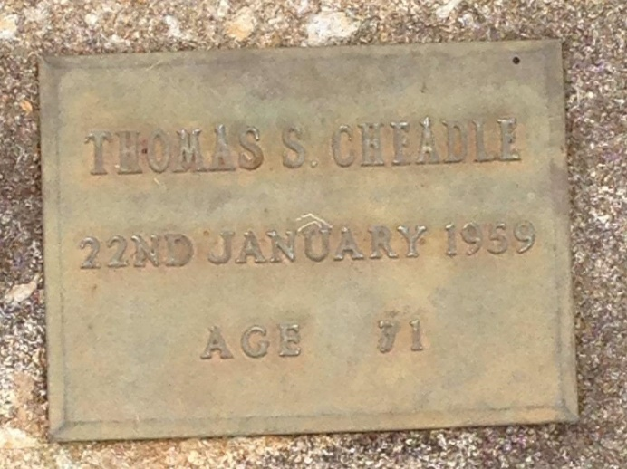 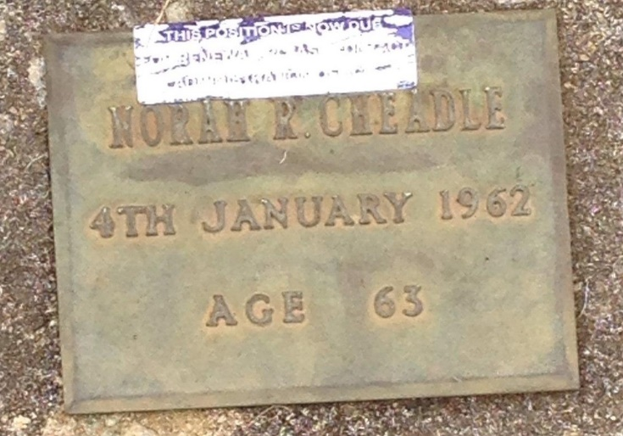

1. Agnes Cheadle

Born – 22nd February, 1891, East Adelaide, South Australia (bk474/pg403)

Died – 1973, Kyneton, Victoria (reg no. 550)

Aged – 81 years

Buried – Macedon Cemetery

Married – 12th April, 1911, Sandriofe, Glenelg, South Australia (bk247/pg108)

(groom – 31, single) (bride – 20, single)

James Hugh Paterson Davis

(parents – Frederick Davis and Sarah Margaret Paterson)

Born – 16th August, 1880, Magill, South Australia (bk246/pg286)

Died – 31st October, 1967, Gisborne, Victoria (reg. no. 6780)

Aged – 87 years

Buried – Macedon Cemetery

Occupation – Stock Agent

1. Agnes Margaret Davis

Born – 31st May, 1912, Glenelg, South Australia (bk888/pg358)

1. Hugh Paterson Davis

Born – 25th March, 1915, Gilberton, South Australia (bk958/pg267)

Died – 11th May, 1965, near Woodville, South Australia (bk992/pg3565)

Aged – 50 years

Last abode – Medindie

Buried – Cremated at Centennial Park Cemetery

1. John Paterson Davis

Born – 1st June, 1916, Gilberton, South Australia (bk981/pg411)

Died – 12th January, 1989, Sutherland, New South Wales

Aged – 76 years

Buried – Woronora Memorial Park, Sutherland, New South Wales – location- Crematorium area JJ, Rose Garden 15, plot 82

Married – 1955, district - Five Dock, New South Wales (reg no. 22805/1955

Claire Margaret Green

(parents – Thomas Arthur Ancel Green and Elsie Irene May Caple)

Born – c. 1921

Died – 30th November, 2007, Adelaide, South Australia

Aged – 86 years

Children –

1. Anna Davis

Born – c. 1956

1. Joan Davis

Born – c. 1958

1. Charles Davis

Born – c. 1960

1. Richard Paterson Davis

Born – 21st August, 1919, Adelaide, South Australia (bk44A/pg36)

Died – 30th May, 1942, France

Aged – 22 years

Buried – Viroflay New Communal Cemetery, France – location – Row A, grave 6

***Military Service***

***Service – WW2, Australian Army***

***Service No. 543613***

Date and place of enlistment – 17th December, 1939, Orroroo, SA

***Service – WW2, Royal Australian Air Force***

***Service no. 407285***

Date and place of enlistment – 17th August, 1940, Adelaide

Next of kin – Nancy Davis

Dated of death – 30th May, 1942

Rank – Flight Sergeant

Posting at death – 460 Squadron

Married – 10th May 1941, Victoria (reg no. 8658)

Nancy McKellar Barratt

(parents – Thomas Barratt and Margaret McKellar)

Born – 11th August, 1916, St Arnaud, Victoria

Died – 2nd January 1990, Bundoora, Victoria

Aged – 73 years

No children

Nancy remarried to Stephen Powell

1. Mary Alison Cheadle

Born – 27th December, 1896, Glenelg, South Australia (bk596/pg76)

Died – 15th March, 1983, Adelaide, South Australia

Aged – 86 years

Buried – Brighton Cemetery

Married – 22nd August, 1929, Congregational Church, North Adelaide, South Australia (bk320/pg443)

(Groom – 28, single) (bride – 32, single)

Commander Jefferson Hirst Walker, M.V.O., D.S.C. R.A.N..

(parents – George William Walker and Fanny Thornton Hammill)

Born – 16th July, 1901, Hawthorn, Victoria (reg No. 19683)

Died – 27th November, 1941, Tobruk

Cause of death – Lost by enemy action off Tobruk

Buried – Plymouth Naval Memorial, Plymouth, Devon, England

Occupation – Navy officer on H.M.A.S. Parramatta 27th

Buried memorial – Brighton Cemetery

***Military Service***

***Service – WW2, Royal Australia Navy***

Date of Birth and location – 16th July, 1901, Hawthorn, Victoria

Date of enlistment and home port – 31st December, 1913, Melbourne, Victoria

Next of kin – Mary Walker

Date of death – 27th November 1941

Rank – Commander

Posting at death – HMAS Parramatta

Honours – Distinguished Service Cross

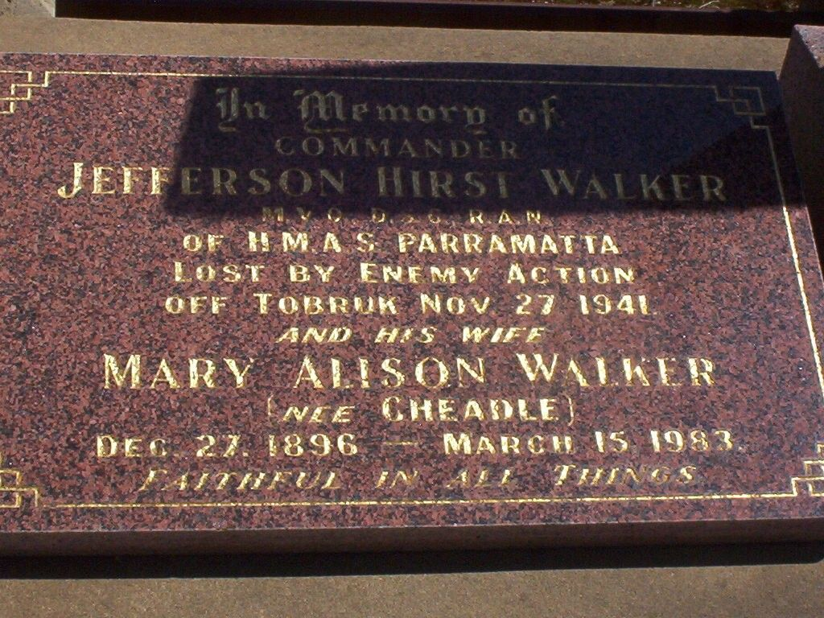

|  |  |  |
| --- | --- | --- |
| Picture  Picture | Picture | **Commander Jefferson Hirst WALKER** Born: 16-7-1901, Victoria Enlisted: 31-12-1913 Royal Australian Navy H.M.A.S. Paramatta Awarded M.V.O. & D.S.C. Died: 27-11-1941, Mediterranean Sea, aged 40years Honoured: Panel 56 Column 1 Australian War Memorial Panel 4 Son of George and Fanny Walker Husband of Mary Alison Walker, of Darling Point, N.S.W. |
|  |  |  |

***The Courier Mail (Brisbane, Qld)  3-12-1941***  
Acting-Commander Jefferson Hirst Walker, M.V.O., D.S.O., R.A.N. He was a Victorian, born in 1901. He entered the R.A.N. College as a cadet midshipman in December, 1914, and went to sea as a midshipmen in January,1919. He became a lieutenant in November, 1922, lieut.-commander in 1930, and was promoted to Acting Commander last September. He specialised in navigation and during his career served in various Royal Australian Navy and Royal Navy ships. He was District Naval Officer for the Northern Territory on the outbreak of  
war. He was awarded the D.S.O. for good service in the present war.

<https://ww2austburialsuk.weebly.com>

1. Frances *Margaret* Cheadle Bsc.Hons

Born – 20th May, 1900, Glenelg, South Australia (bk659/pg312)

Died – 14th August, 1995, Adelaide, South Australia

Aged – 95 years

Buried – Brighton Cemetery

Occupation – Scientist – insulin researcher, prolific author.

Married – 18th November, 1927, St Laurence Church, North Adelaide, South Australia (bk313/pg589)

(groom – 24, single) (bride – 27, single)

Dominic Mary *Paul* McGuire CBE

(parents – James McGuire and Mary O’Sullivan)

Born – 3rd April, 1903, Petersburg (Peterborough), South Australia (bk711/pg249)

Died – 15th June, 1978, Adelaide, South Australia

Aged – 75 years

Buried – Brighton Cemetery

Occupation – Ambassador to Italy, Maritime historian.

The Paul McGuire Maritime Library at the State Library of South Australia was established and named in his memory.

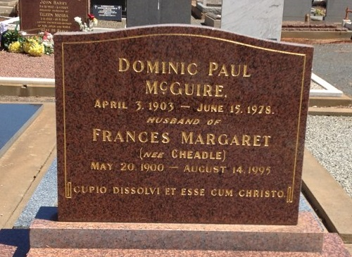

# Author: Frances Margaret Cheadle McGuire

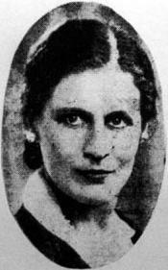

**Date of birth:** 20 May 1900  
**Date of death:** 14 August 1995  
**Website:** [www.bookerworm.com](http://www.bookerworm.com)

Frances Margaret Cheadle McGuire was born in Glenelg, South Australia, the daughter of a wealthy Protestant family of Scottish-English parentage. She was tutored at home and traveled to Europe during her childhood. She earned a Science degree from Adelaide University. She worked as a biochemist at Adelaide University, researching insulin. In 1927 she married, converted to Catholicism, and moved to England. In the early 1930s she returned to Adelaide, although she and her husband continued to travel to Europe and the United States. Her husband, Paul McGuire was the Australian ambassador to Ireland in 1953 and ambassador to Italy from 1957-1959. Frances McGuire was the author of ten books, including an autobiography of the first 14 years of her life, a detective novel, and two officially commissioned Australian Navy histories.

# *Mr Dominic Mary Paul McGuire*

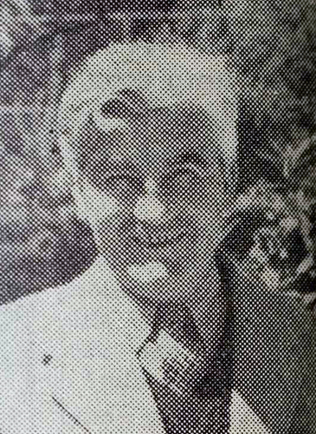

**Dominic Mary Paul McGuire** (1903-1978), author and diplomat, was born on 3 April 1903 at Petersburg (Peterborough), South Australia, ninth son of James McGuire, superintendent of local railway traffic, and his wife Mary, née O'Sullivan, a former schoolteacher. When James was promoted Commissioner of Railways in 1917, the family moved to Adelaide. Paul had attended Christian Brothers' College, Wakefield Street, from 1914. He earned pocket money by writing paragraphs for the *Bulletin*, 'anything up to five bob or ten bob a week when I was eleven years old'. Aged about 12, he began to have verse accepted and to think of himself as a writer. His adolescence was marked by recurrent mourning-three brothers in the Australian Imperial Force were killed, a fourth died of wounds, another of consumption; and his only sister Mary Genevieve died shortly after childbirth, with her infant. The dramatic and repeated experience of loss as a boy was mirrored in the intense depressions McGuire suffered as a man, as well as in continuing themes of the fragility of life and happiness in his writing.

At the University of Adelaide from 1923, he read history under Professor George Henderson, whom he admired and credited with confirming that 'history was not looking back; history was essentially deciding where we are'. McGuire was Foundation President (1924-25) of the Adelaide University Dramatic Society, Editor (1925) of the university magazine and a debater in the team that met visitors from Oxford. He left university to work as a journalist. At St Laurence's Catholic Church, North Adelaide, on 18 November 1927 he married Frances Margaret Cheadle, three years his senior. He had met her at the university while she was launching a research career in biochemistry. Their engagement stunned their friends, but the marriage was a meeting of minds, passions and aspirations. Margaret-a Congregationalist whose family moved in the best of Adelaide's Protestant circles-converted to Catholicism. They set up house in Adelaide, and then in a shooting-hut at Belair, writing for the *Bulletin* and running a literary page in the diocesan Catholic weekly, *Southern Cross*, while Paul taught history and English as a casual lecturer for the Workers' Educational Association of South Australia. Next year they left for London.

In contrast to Irish-Catholicism in Adelaide, McGuire was dazzled by the intellectual, and cheerfully counter-cultural, circle of English Catholic writers around G.K. Chesterton and Hilaire Belloc. McGuire's training in London with the Catholic Evidence Guild equipped him for 'Speakers' Corner' at Hyde Park, where the guild promoted a Catholic world-view based on traditional doctrine, 'Chesterbelloc' philosophy (including Distributism) and the social encyclicals. He also read and, in 1937, eventually met, the Belgian priest Fr Joseph Cardijn, founder of the Jeunesse Ouvrière Chrétienne (Young Christian Workers). Like Belloc, Cardijn impressed him with hearty and good-humoured spirituality. McGuire was inspired by the challenge to be 'a fool for Christ' and flourished in a self-consciously Catholic atmosphere charged with intellectual endeavour and a mission to reform the modern state. He wrote poetry with a sense of vocation, and made contacts with literary and Catholic periodicals that would later carry his articles. His direct encounter with Cardijn and his clear understanding of Jocist Catholic Action set him apart from later Catholic activists in Australia.

In 1932 McGuire was welcomed back to Australia by the *Bulletin* as a model for other authors seeking to publish in London. In Adelaide he continued to write. The poetry he had penned in England was included in anthologies and collected in *The Two Men and Other Poems* (1932). To pay 'the butcher and baker (and in honesty...the brewer)', he wrote detective stories (as he had done in London), sometimes two or three a year, claiming they took three weeks to complete (though once as little as four days). His fifteen mystery novels were published by 1940. Two in particular cemented his reputation as a 'most satisfying person with whom to go a murdering': *Burial Service* (London, 1938) and *The Spanish Steps* (London, 1940). His non-formulaic plots gave the characters range to express opinions; and heroes were often in tune with his philosophy.

Appalled to find the 1931 papal encyclical, *Quadragesimo Anno*, was difficult to buy in Australia in 1932, Paul, Margaret and Fr James O'Dougherty founded the Catholic Guild for Social Studies to raise awareness of Catholic principles so that ordinary members of the church could 'win the world'. Their patron 'saints' were St Thomas Aquinas and the then uncanonised layman Sir Thomas More. The first members were mostly unemployed young people. The guild's four-part programme of prayer, study, social action and recreation attracted two thousand participants in the first year as groups formed in parishes, in the railways and post offices, and among nurses in hospitals and schoolboys at Christian Brothers College. The guild prompted the foundation of a Catholic library in Adelaide, and provided its initial stock. Links were made with developing groups in other States, and in 1934 McGuire spoke on Catholic Action to the meeting of Catholic intellectuals held in conjunction with the National Eucharistic Congress, Melbourne.

In addition to running courses for the guild, McGuire lectured for the Workers Education Association (WEA) on literature and history. In 1936 the guild swung to the right (with much of Western Catholic thought) in support of General Franco's cause in the Spanish Civil War. McGuire travelled to Spain as correspondent for the *Catholic Herald* (London), and wrote passionately of the children displaced by the conflict and the damage done to the Catholic culture of Europe. With Father John Fitzsimmons, he published *Restoring All Things* (London, 1939), a discussion of the wide-ranging aims of Catholic Action. It attracted international attention. The American Catholic benevolent society, the Knights of Columbus, invited McGuire to lecture on 'The Christian Revolution' across the United States of America; his tour of 1939-40 regularly attracted crowds of 3500, and was credited with precipitating the Christian Family Movement.

Aiming to introduce Australia to non-specialists, McGuire had published *Australian Journey* (London, 1939). The Australian delegation in Washington requested copies to give as gifts, and R.G. (Baron) Casey wrote to introduce him to Prime Minister Curtin as one 'who has a lot more useful work up his sleeve'. Although McGuire freely admitted in retirement that his mind had never been 'exact enough' for history, a system of research support-led by Margaret, Emilie Woodley and Betty Arnott-provided accurate details for several works blending history and public comment. *Westward the Course!: the New World of Oceania* (New York, 1942) proved a best seller, given Americans' interest in the Pacific after the bombing of Pearl Harbor. *The Price of Admiralty* (Melbourne, 1944), written with Margaret, told the story of HMAS *Parramatta* and her commanding officer JH Walker.

Commissioned on 12 August 1942 in the RANVR, McGuire performed intelligence duties in Melbourne as Deputy-Director of Psychological Warfare, Far Eastern Liaison Office. He was demobilised as lieutenant on 4 May 1945, but was to remain in the RANVR until 1958, retiring as an honorary commander. Sent to Europe in 1945 as a war correspondent, he covered the work of the United Nations International Children's Emergency Fund and promoted the emigration of British ex-servicemen to Australia. He also claimed to have carried out 'special intelligence operations'.

In 1946 McGuire again lectured in North America, and toured northern South Australia with (Sir) Thomas Playford, forging a long-standing friendship over bottles of milk for the Premier and whisky for himself. In 1947 he began discussions with Oxford University Press about editing a series on Australian social history. Although the proposal was never realised, he published two books as preliminary instalments, *The Australian Theatre* (Melbourne, 1948) and *Inns of Australia*(Melbourne, 1952), both with Margaret and Arnott. Margaret McGuire, always a strong supporter of the RAN, also published *The Royal Australian Navy*, its origin, development and organisation in 1948.

Two works of social analysis at the close of the 1940s lifted McGuire into a fuller public role. In *The Three Corners of the World* (London, 1948) he argued that the British Commonwealth's model of cooperation between states should be adopted in the free world, with the United States moving to the hub. *There's Freedom for the Brave* (London, 1949) advocated an urgent increase in moral power and the restoration of true community (symbolised by freer trade) as a cure for the postwar crisis of the West. The book was favourably reviewed, and prompted (Sir) Robert Menzies to make McGuire a personal adviser for the 1951 British Commonwealth prime ministers' meeting in London. McGuire was appointed CBE (1951).

Discussions at that meeting gave shape to plans for a non party political campaign to revitalise Australian moral life and strengthen the bulwarks against communism. McGuire drafted a statement on the steps of St Peter's Basilica during a stopover in Rome, and contacted Sir Edmund Herring, a former Chief Justice of Victoria, who agreed to lead the campaign which became 'A Call to the People of Australia'. A flurry of semi-secret meetings between business leaders and ex-servicemen provoked questions in the Senate about McGuire's role in a sinister 'New Guard'. The government answered the question with a statement on spiritual renewal. Broadcast on 11 November 1951, with signed support from State governors, chief justices and church leaders, the 'Call' urged a return to values of civic duty, loyalty and moral strength. To maintain the momentum of overwhelming support, standing committees were established and McGuire directed the national campaign until 1953.

Named Australian Ambassador to Ireland in April that year, McGuire was a delegate to the session of the United Nations' General Assembly in New York which opened in September. Following a dispute over his 'letters of credence', his appointment to Dublin was cancelled in January 1954. He served instead as Minister (1954-57) and Ambassador (1957-59) to Italy. He gloried that he was Australia's Special Ambassador and Envoy to the Holy See for the funeral of Pope Pius XII and the coronation (1958) of Pope John XXIII, but seems to have fretted at being 'a minor organ of the body politic'. For many years he belonged to the Savile and Athenaeum clubs in London, and the Naval, Military (and Air Force) Club in Melbourne. He was appointed (commander) to the Order of Merit of the Republic of Italy in 1967.

The McGuires had returned to Adelaide in 1959 with plans for more books. Writing was impossible while Paul underwent two operations to treat the retina in his eye. In the 1960s and 1970s he wrote television scripts for the Rank Organisation in Britain, and began a series of interviews with South Australian sportsmen, but a round of public-speaking engagements replaced the stream of articles and books. He also worked with the Good Neighbour Council of South Australia. Appointed (Grand Cross) to the Order of St Sylvester in 1959, he valued his papal knighthood as much for the tradition it endorsed as the achievements it recognised. McGuire was surprised at the talk of crisis in the Church following Vatican Council II. He saw the issues as grim moral and intellectual problems in society-not simply in the Church-and as part of a cycle of centuries.

McGuire died on 15 June 1978, the year of celebrations for the five centuries since Thomas More's birth, at Calvary Hospital, North Adelaide, and was buried in Brighton cemetery. Tributes noted that More's commemoration would have been unthinkable without wide acceptance of McGuire's belief in the value of an intellectual apostolate and the significance of lay people in the church. His wife survived him, and in 1979 donated his collection of 180 books on maritime subjects, with funds for maintaining them, to establish the Paul McGuire Maritime Library at the State Library of South Australia. In 1980 she prompted the posthumous publication of a selection of his best poems.

*Katharine Massam*

*Image: News (Adelaide SA), October 1950*[*Trove, National Library of Australia*](http://trove.nla.gov.au/newspaper/article/131219980?searchTerm=paul%20mcguire&searchLimits=l-decade=195|||l-year=1950|||l-state=South+Australia|||l-title=461)

Source – [www.navy.gov.au](http://www.navy.gov.au)

1. Peter Roland Cheadle

Born - 9th September, 1906, Glenelg, South Australia (bk771/pg220)

Died – 31st March, 1985, South Australia

Aged – 78 years

Buried – Enfield Memorial Park Cemetery – cremated – location – RC, CGV, site 8

Abode – Walkerville, they had residences ‘Medindie’ and ‘The Shay”, Mount Lofty.

Married – 23rd January, 1932, St Andrews Church, Walkerville, South Australia (bk330/pg148)

(groom – 25, single) (bride – 27, single)

Jessie Stodart

(parents – Edwin Charles Stodart and Caroline Jane Correll)

Born – 1st January, 1902, Parkside, South Australia (bk689/pg302)

Died – 30th October, 1997, Walkerville, South Australia

Aged – 95 years

Buried – Enfield Memorial Park Cemetery – cremated – location – RC, CGV, site 8

